Math 4 Honors Name __________________________
Unit 6 Test Review Date ______________________

- Short essay questions based off of your notes & vocabulary

- Use the average rate of change (slope) formula

- Use the Power Rule to differentiate of a function

- Use the derivatives and number line analysis to find the coordinates of the local extrema (max/min), the coordinates of the inflection point(s) and concavity of a function.
Try this function: f(x) = x³ – 1.5x² – 18x

Write the equation of a tangent line to f when x = -4.

- Use the position, velocity & acceleration functions to solve vertical motion & particle motion problems.

- Sketch & label the graph of a function given certain criteria.

If f is a function such that:
f ’(1) = 0
f ’(-3) = 0
f’’(x) < 0 for –1 < x < 1
f’’(x) = 0 when x = -1 and x = 1
f’’(x) > 0 elsewhere,
graph f as best you can.

- Three Optimization Problems

Unit 6 Vocabulary

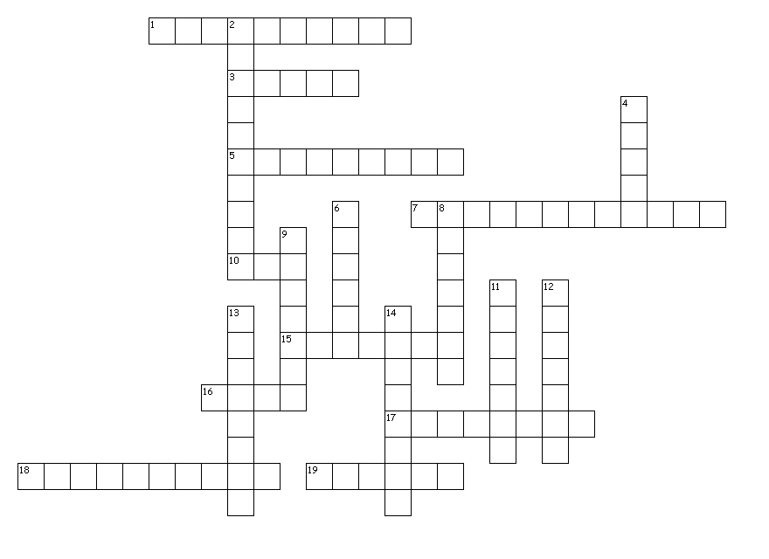

Across
1. The slope of the tangent line for any given value of x for a real, continuous function
3. The ______ derivative of a function helps determine where the function is increasing or decreasing.
5. The second derivative of a function helps determine the function's _____.
7. _______ is the second derivative of position.
10. When solving an optimization problem, you use _______ (initials) to justify your solution.
15. When f '(x) = 0, there is a relative ______ point.
16. In a particle motion problem, when f ’(x) < 0, the particle is moving to the _______.
17. The mathematics of change
18. The tangent lines are ______ at a function’s extrema.
19. _______ (last name) is credited with founding calculus.

Down
2. The point where a function’s concavity changes is called the point of _______.
4. In a particle motion problem, when f ’(x) > 0, the particle is moving to the _______.
6. A line that connects two points of a function.
8. At the point of inflection, the graph ______ its tangent line.
9. The ______ lines are above the function when f ”< 0.
11. When f ' switches from positive to negative, there is a relative _______ for f.
12. When f ' switches from negative to positive, there is a relative _______ for f.
13. Taking higher powers of a function (“climbing up the ladder”)
14. _______ is the first derivative of position.

